Synopsis Report on

House Rental Management System

Submitted by

Akshay Kalapgar [T-631]

&

Mohit Kamble [T-632]

Guided by

Prof. Nilesh Rathod

**DEPARTMENT OF INFORMATION TECHNOLOGY**

**UNIVERSITY OF MUMBAI**

**2020**



**DEPARTMENT OF INFORMATION TECHNOLOGY**

*CERTIFICATE*

Date: ____________

This is to certify that, the project work embodied in this report entitled, *“****House Rental Management System****”* submitted by “***Akshay Kalapgar*** *bearing Roll No*. 631”, “***Mohit kamble*** *bearing Roll No*. 632” for the award of Third year ***of Engineering(T.E.)***degree in the subject of ***Information Technology****,* is a work carried out by them under my guidance and supervision within the institute. The work described in this project report is carried out by the concerned students and has not been submitted for the award of any other degree of the University of Mumbai.

Further, it is to certify that the students were regular during the academic year 2018-2019 and have worked under the guidance of concerned faculty until the submission of this project work at ***Rajiv Gandhi Institute of Technology, Mumbai.***

Prof. Nilesh Rathod

**Project Guide**

Dr. Sunil B. WankhadeDr. Sanjay U. Bokade

**Head of Department Principal**

CERTIFICATE OF APPROVAL

This synopsis report entitled

*House Rental Management System*

Submitted by:

Akshay Kalapgar [T-631]

&

Mohit Kamble [T-632]

In partial fulfillment of the requirements of the degree of Third year **of Engineering** in **Information Technology** isapproved.

**Internal Examiner**

**____________________**

**External Examiner**

**_____________________**

Date:

Place:

Declaration

I declare that this written submission represents my ideas in my own words and where others' ideas or words have been included, I have adequately cited and referenced the original sources. I also declare that I have adhered to all principles of academic honesty and integrity and have not misrepresented or fabricated or falsified any idea/data/fact/source in my submission. I understand that any violation of the above will be cause for disciplinary action by the Institute and can also evoke penal action from the sources which have thus not been properly cited or from whom proper permission has not been taken when needed.

**ROLL NO. NAME SIGNATURE**

631 Akshay Kalapgar

632 Mohit Kamble

Date:

Place:

**Acknowledgement**

With all reverence, we take the opportunity to express our deep sense of gratitude and wholehearted indebtedness to our respected guide, **Prof. Nilesh Rathod**, Department of Information Technology, Rajiv Gandhi Institute of Technology, Mumbai. From the day of conception of thisproject his active involvement and motivating guidance on day-to-day basis has made it possible for us to complete this challenging work in time.

We would like to express a deep sense of gratitude to our respected **Head of the Department**, Dr.**Sunil B. Wankhade**who went all the way out to help us in all genuine cases during the course of doing this project. We wish to express our sincere thanks to **Dr. Sanjay U. Bokade**,**Principa**l, Rajiv Gandhi Institute of Technology, Mumbai and would to like to acknowledge specifically for giving guidance, encouragement and inspiration throughout the academics.

We would like to thank all the staff of Information Technology Department who continuously supported and motivated during our work. Also, we would like to thank our colleagues for their continuous support and motivation during the project work. Finally, we would like to express our gratitude to our family for their eternal belief in us. We would not be where we are today without their support and encouragement.

Akshay Kalapgar

Mohit Kamble

Date:

Place:

**TABLE OF CONTENTS**

|  |  |  |
| --- | --- | --- |
| **Sr. No.** | **Chapter** | **Page No.** |
| 1. | Abstract | 7 |
| 2. | Introduction | 8 |
| 3. | Aims and objectives | 9 |
| 4. | Literature Survey | 10 |
| 5. | Requirements Definition | 11 |
| 6. | Proposed System | 12 |
| 7. | Detailsof Hardware & Software | 14 |
| 8. | Conclusion | 15 |
| 9. | References | 16 |

**CHAPTER 1: ABSTRACT**

A majority of unpleasant issues faced by landlords and tenants seem to grow due to lack of communication. Late rent payments turn into an eviction. A non-functional AC or a broken window becomes a reason to break a lease. Fortunately, building a positive relationship doesn't take much effort and it all starts with one basic idea: communication. House Rental Management system provides the solution by offering the ability to share issues between tenants and landlords which lead to rapid issue resolution and fewer misunderstanding. The goal of the app is to create a better relationship between tenants and landlord. The House Rental Management system is designed to support both tenants and landlords by enabling them to document and communicate repair issues, send automatic rent reminders, package notifications and emergency information. It helps the tenant with making Payments and it also helps the Landlord to keep track of issues posted by tenants. Effectively resolving the apartment issues is important to the tenant's long term future and the House Rental Management system app will be an important tool for creating rental housing stability by helping tenants speak with greater credibility through initiating and documenting communications and building productive relationships with landlords.

**CHAPTER 2: INTRODUCTION**

House Rental Management System is developed using PHP, CSS, bootstrap, and JavaScript. Talking about the project, it contains an admin side from where a user can manage the house, tenants, payments, and much more. In this project, the user has to perform all the main functions from the Admin side.

Talking about the features of the House Rental Management System, the admin can manage the house by entering details such as house number, features, rent, and status. In order to add tenants, the user has to enter the full name, gender, national id, phone number, email, registration date, house, agreement document, status, and exit date. Besides, the admin can add invoices and payments too. For payment, the user has to select a tenant, paid amount, balance, date, and comments. Other features include displaying of remaining payments.**CHAPTER 3: AIMS & OBJECTIVES**

**AIM:** Software for a house rental management system that promises to get to see all types of properties online without visiting it personally just to save time and money.

**OBJECTIVES:**

* Login/Register System
* Manage House, Tenant
* Manage Invoice, Payments
* View Remaining payment, in complete payments

**CHAPTER 4: LITERATURE SURVEY**

In a house rental management system is proposed which will keep track of user reservations smartly. Basically, they implemented a house renting system for different type of properties in which user will make reservations of houses by one click only.

In there was an attempt to design and implementation of digital house rental using online technology. This system was a basic dynamic database utility system which fetches all information from a centralized database. This application improved the accuracy and efficiency of restaurants as well as human errors. Earlier drawbacks of house renting (offline) were overcome by this system.

In an application of integration of house rental management systems by web services technology is presented. Billing System, Customer Relationship Management system (CRM) is held together by the Digital house rental management. Add or expand of house renting system in any size of properties in environment was possible with this solution.

In research work aims to design and develop online house renting system in the properties. Technical operations including systems architecture, function, limitations and recommendations were presented in this system. By providing higher quality customer service and reducing human errors to improve the management aspect for properties, pervasive application will be a valuable tool due to the high demands of handheld devices such as PDAs.

**CHAPTER 5: REQUIREMENT DEFINITION**

Analyzes based on similar application and determines the necessary features in the application, as well as do the details about the features that will be created with function of each features. Features that are needed in application for customer are as follows:

* **New Reservation**: New Reservation is the main feature of the customer side application that will be used to make reservations. A reservation can be made in two separate ways, the one is by is using My Favorites feature to make an order by choosing one of the top three favorites types of properties and the other one is by using Make a new reservation feature to make a reservation by choosing property and menus provided easily.
* **Reservation History**: Customer’s reservation history is shown by this feature namely reservation history.
* **Property Profile**: Property’s profile is shown by this feature. Through this feature customer can make call to the property directly.
* **Reservation Status**: This feature is used to show that reservation status that includes “reservation received” means that property has received the reservation, “reservation confirmed” means that reservation has confirmed the reservation.
* **Profile Setting**: To show and to change customer profile this feature is used that comprise of name, address, email, and phone number.

**CHAPTER 6: PROPOSED SYSTEM**

To overcome the restrictions of above system, based on Internet of Things an Online House Rental System is proposed. The use of online technology has revolutionized as the Android devices have gained popularity in the automation of routine task in wireless environment. For mobile devices such as smart-phones and tablets android is a Linux built operating system. As a general Objective of the study to develop a reliable, convenient and accurate House Renting System is considered. As an objective, a system that will surely satisfy the customer service will be considered. To design a system that can accommodate huge amount of reservations at a time and automatically compute the bill is one of the key objectives. One of the important objectives is to evaluate its performance and acceptability in terms of security, user-friendliness, accuracy and reliability. One of key objective is to improve the communication between the tenants and landlords. The figures represent the data flow diagrams of the proposed system: -

DFD level 0:

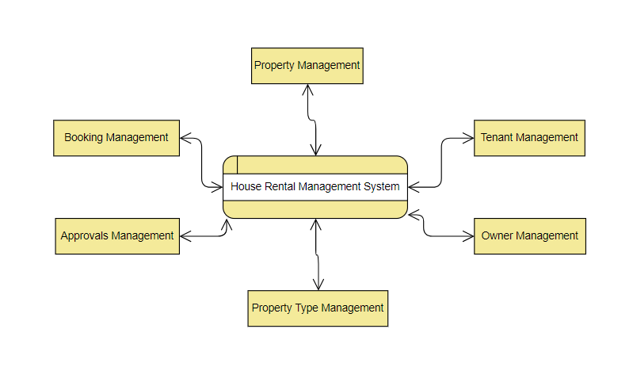

DFD level 1:

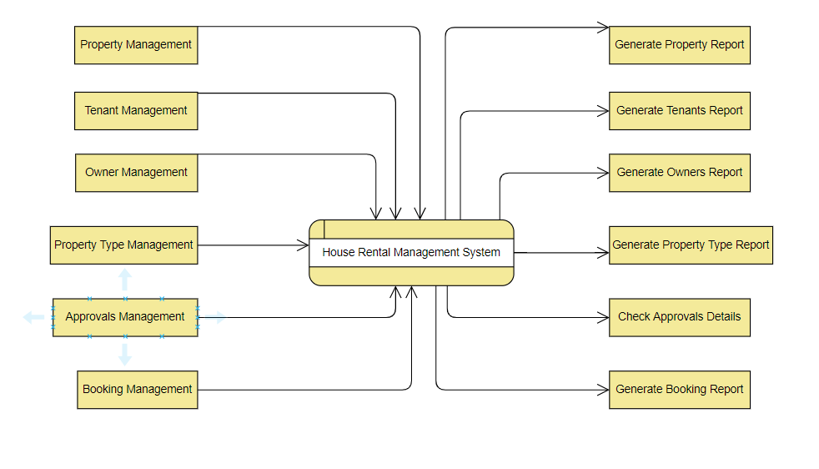

DFD level 2:

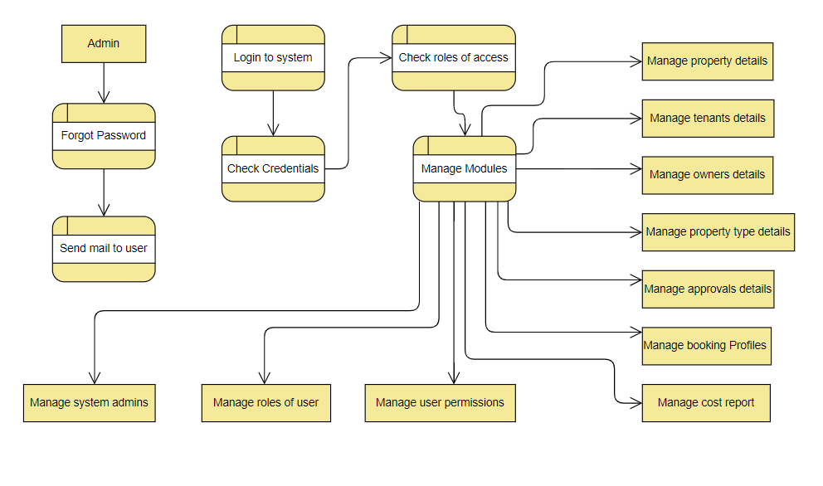

**CHAPTER 7: Details of Hardware & Software**

Using the storyboard design, we construct the application design workflow for restaurant, customer, courier and admin side; the user experience design. The use case, class diagram, sequence diagram, activity diagram and database structure design are comprised in the Unified Modeling Language.

* **Storyboard design**: Designing the user interface is done by storyboard design which includes each interface description.
* **User experience design**: When interacting with the application, designing the totality of end user perception this design is used.
* **UML design**: The UML design contains use case to define the system function from each actor perspective then accomplished by explanation in use case narrative, to draw the process of each actor in diagram activity diagram is used, to draw object or class of system with its relationship class diagram is used and to draw the message interaction with its objects base on its order of time sequence diagram is used.
* **Database structure design**: By the result of class diagram, database structure design is made. Classes that need to be saved in database and its relationship are drawn by this design.

**CHAPTER 8: CONCLUSION**

The application is based on user’s requirement and is user centered. All issues related to all user which are included in this system are developed by this system. If people know how to operate internet wide variety of people can use the system. This system will solve the various issues related to renting service. To help and solve important problems of people implementation of Online House Rental system is done. It can be concluded that, based on the application: Reservations are made easily by this system; Information needed in making reservations to landlord is provided by the system. Receiving reservations and modifying its data is possible through the system and it also helps admin in controlling all the house renting system.

**CHAPTER 9: REFERENCES**

[1]. Kirti Bhandge, Tejas Shinde, Dheeraj Ingale, Neeraj Solanki, Reshma Totare,”A Proposed System for Touchpad Based House Renting System Using Android Application”, International Journal of Advanced Research in Computer Science Technology (IJARCST 2015).

[2]. Varsha Chavan, Priya Jadhav,SnehalKorade,PriyankaTeli, ”Implementing Customizable Online House Renting System Using Web Based Application”, International Journal of Innovative Science, Engineering Technology(IJISET) 2015.

[3]. Resham Shinde, Priyanka Thakare, Neha Dhomne, Sushmita Sarkar, ”Design and Implementation of Digital Renting Properties using Internet”, International Journal of Advance Research in Computer Science and Management Studies 2014.

[4]. Ashutosh Bhargave, Niranjan Jadhav, Apurva Joshi, Prachi Oke, S. R Lahane,“Digital renting system for Properties Using Internet”, International Journal of Scientific and Research Publications 2013.

[5]. Khairunnisa K., Ayob J., Mohd. Helmy A. Wahab, M. ErdiAyob, M. IzwanAyob, M. AfifAyob, ”The Application of Online House Rental management System” MASAUM Journal of Computing 2009.